LegalAid Connect – Phase 3: Data Modelling & Relationships Report

Project Title: LegalAid Connect – Legal Aid CRM

Phase: 3 – Data Modelling & Relationships

Date: 24 September 2025

Prepared By: SRIJITHA G

# Introduction

Phase 3 focused on designing the data architecture for LegalAid Connect.

The goal was to create custom objects, fields, and relationships that accurately represent the legal case management ecosystem. This ensures scalability, usability, and the ability to trace client cases, hearings, and legal orders from intake to closure.

# Object Model Design

Core objects identified and configured:

* **Client (Contact – Standard)**

Fields: Client ID (Auto Number), Name, Gender (Picklist), Address, Phone, Email

Relationship: N/A

* **Case (Custom: LA_Case__c)**

Fields: Case ID (Auto Number), Case Type (Picklist: Criminal, Civil, Family, Labour), Case Status (Picklist: Intake, Open, In Court, Closed), Summary

Relationships: Lookup → Client (Contact), Lookup → Assigned Lawyer (User)

* **Hearing (Custom: LA_Hearing__c)**

Fields: Hearing Date/Time, Court Location, Outcome

Relationship: Master-Detail → Case, Lookup → Lawyer (User)

* **Order (Custom: LA_Order__c)**

Fields: Order ID (Auto Number), Judge Name, Order Date, Final Status (Picklist: Pending, Approved, Rejected)

Relationship: Lookup → Case

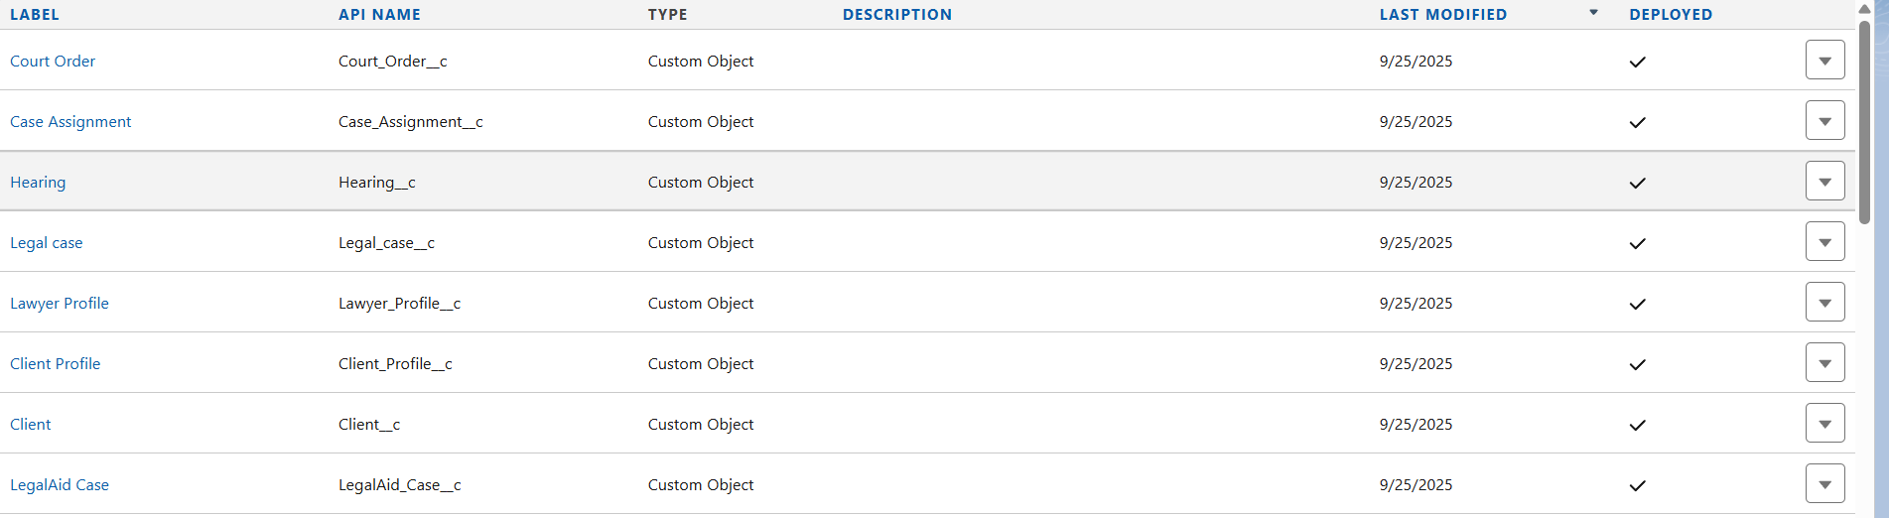

# Relationships Defined

* Client → Case: One client can have multiple cases (Lookup)
* Case → Hearing: One case can have multiple hearings (Master-Detail)
* Case → Order: One case can have multiple orders (Lookup)
* Lawyer (User) → Case / Hearing: Assigned lawyer linked via Lookup

# Page Layouts & Record Types

* **Client Layout:** Basic client information (Name, Contact, Address, Gender)
* **Case Layout:** Includes case details, client information, related hearings and orders
* **Hearing Layout:** Displays hearing date, case, assigned lawyer, court location, outcome
* **Order Layout:** Shows order details, case, judge name, and status

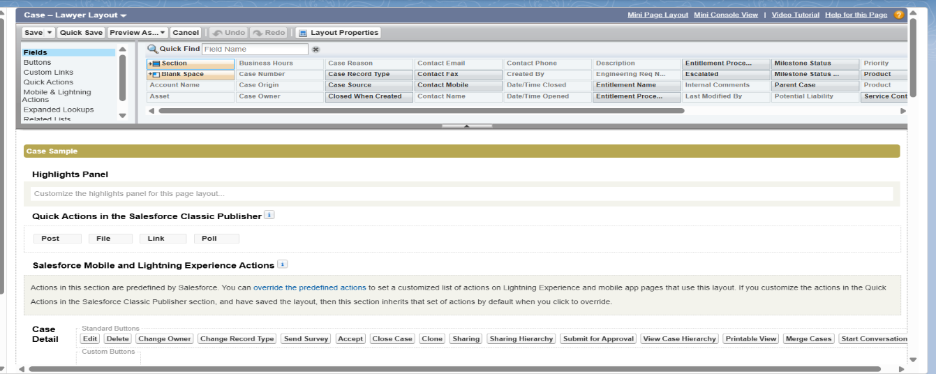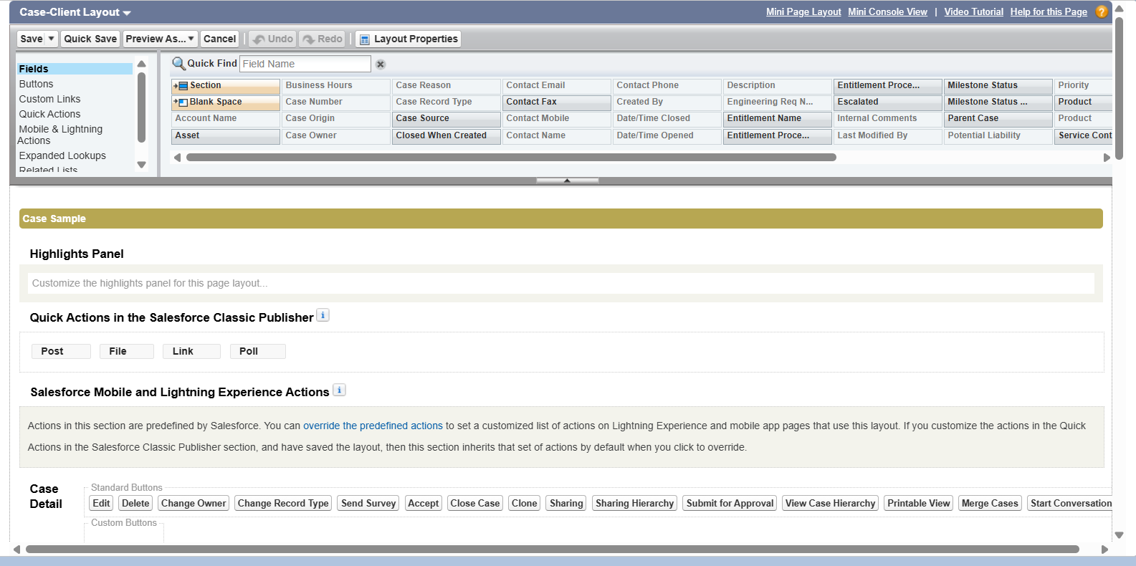

* Record Types:
* **Case:** Criminal, Civil, Family, Labour
* **Order:** Standard vs Special Orders (optional for workflow purposes)

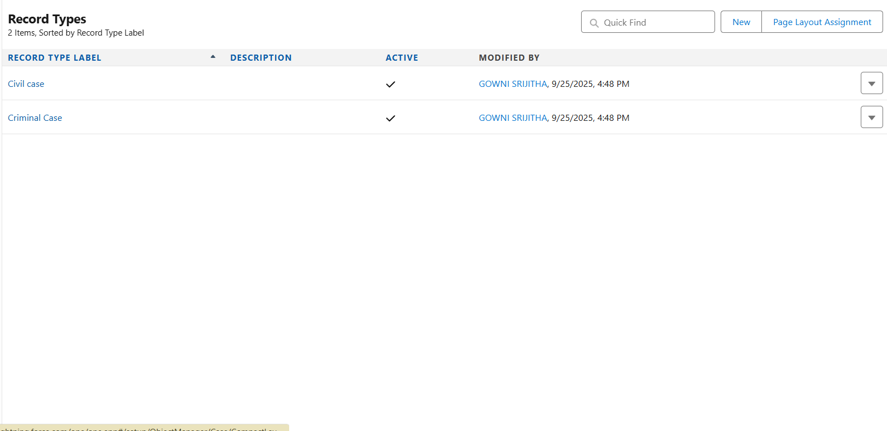

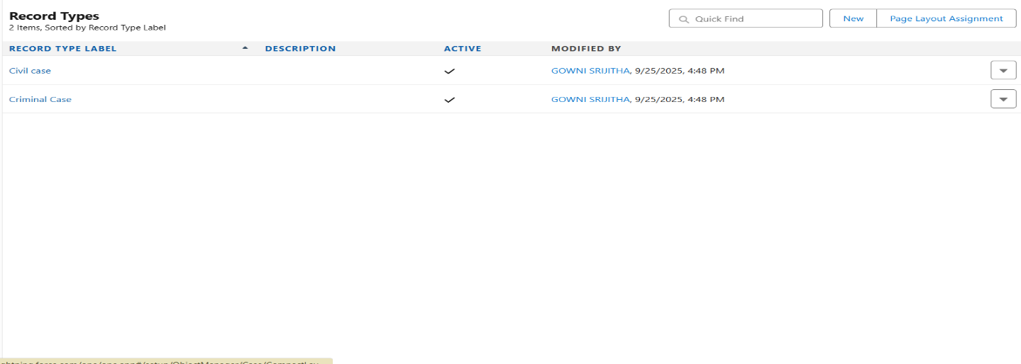

# Compact Layouts

Compact layouts configured for better Salesforce Mobile experience:

* **Client:** Name, Phone, Email
* **Case:** Case ID, Case Type, Status
* **Hearing:** Hearing Date/Time, Lawyer, Case
* **Order:** Order ID, Case, Final Status

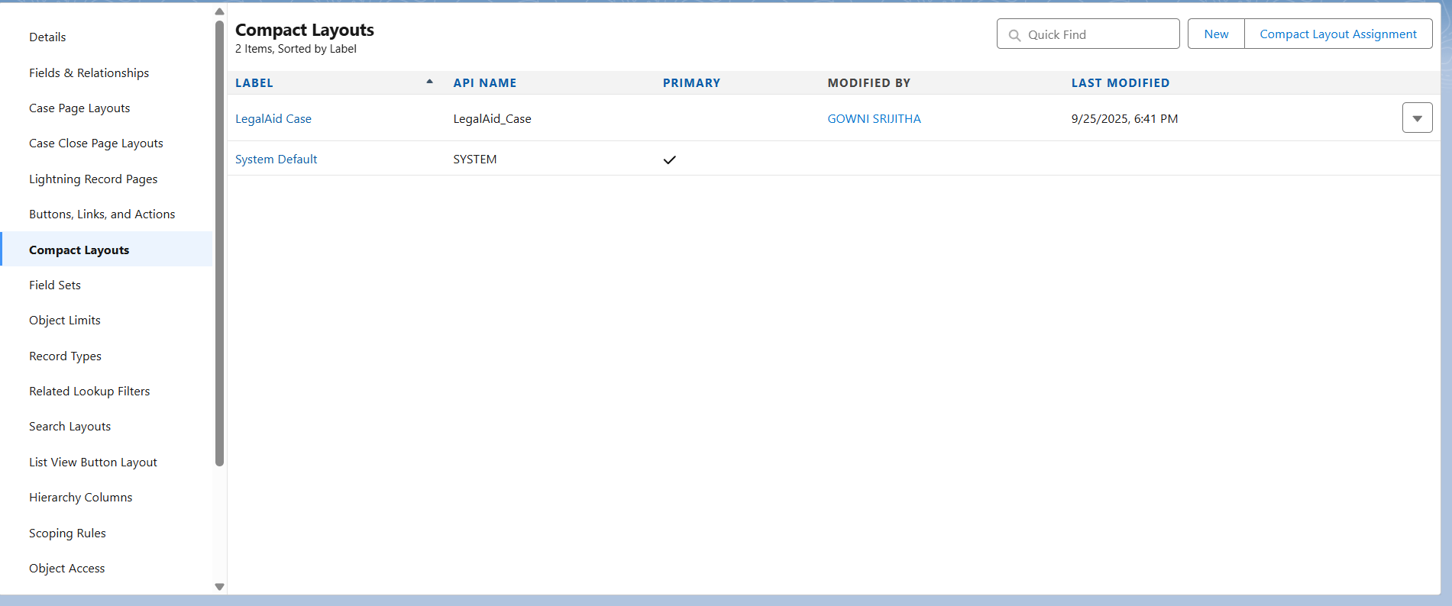

# Schema Builder Visualization

All objects and relationships were mapped using Salesforce **Schema Builder**.

The schema diagram provides a clear, visual understanding of how the legal CRM data model is structured.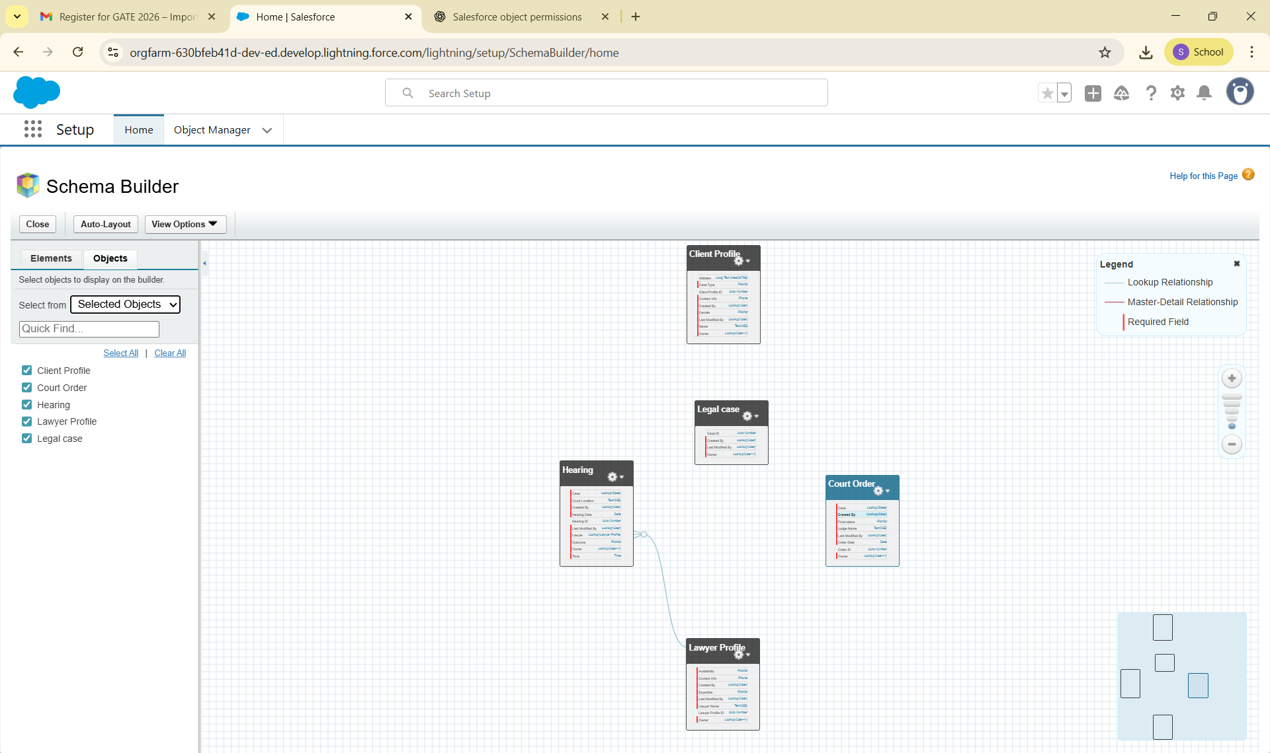

# Challenges & Learnings

* Learned to differentiate Lookup vs Master-Detail relationships and when to apply each
* Understood how related lists improve record traceability
* Hands-on experience with Schema Builder enhanced understanding of data model design
* Designing compact layouts improved awareness of mobile-first considerations

# Next Steps

With Phase 3 completed, the project is ready to proceed to **Phase 4: Process Automation**. Next activities:

* Create **Validation Rules** for data accuracy
* Build **Process Builder and Flow automations** for intake, case assignment, and reminders
* Setup **Approval Processes** for legal orders

**Phase 3 Completion Status: DONE**

# Prepared for Phase 4 Development